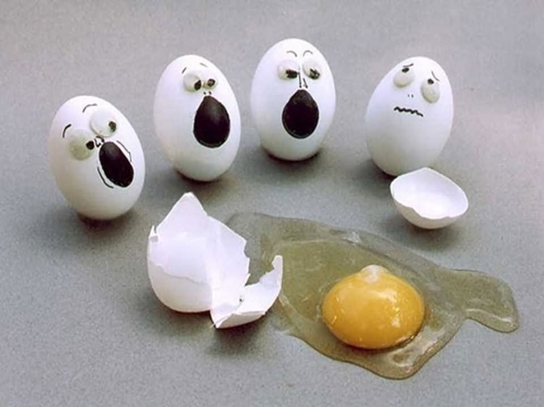

PROJE CT-BASED LEARNING:

EGG-CITING EGG CRASH

|  |  |
| --- | --- |
| **Description**  You are the newly hired Automotive Engineering Team for JEA Motors Inc. - a newly emerging vehicle design company that is planning to build and sell the safest automobiles ever built.  The CEO of the company, Mr. Mandl, has hired you to design and build the company’s first commercially available vehicle - developed to ensure the safety of its passengers during any impact situation. The automotive industry is constantly striving towards a higher level of safety in today’s automobiles. Each new model line must pass through rigorous testing and standards. Perhaps the most important testing that occurs is the crash testing. Vehicles are crashed into walls or other cars to determine if the occupants would survive a real life crash, and the types of injuries they could sustain. Will your passengers survive? | **Requirements**  Ideal submissions will meet the following requirements:  1. You must complete all required work for the project by the due dates in order to participate in the crashes  2. Your car must adhere to all constraints as detailed in the handouts  3. Your work must be neat and organized with approvals from your instructor as needed  4. Meet the due dates – If you do not submit by the due date, your car will not crash tested and you will receive a failing grade for the project |
| **Deliverables**   * Individual Research: Safety Worksheets * Team Concept Phase: Sketches * Team Build Phase: Vehicle Development * Team Testing Phase: Crash Tests * Final Item: Checklist |

|  |
| --- |
|  |
| **CPC CAD: PROJECT-BASED LEARNING** | EGG-CITING EGG CRASH |
| **DAILY DIRECTIONS:** |

**Days 1 & 2: Individual Research Work Phase**

* Complete the *Automobile Frame Research* assignment on pages 5 and 6
* When finished, save in your segment 12 folder
* Print pages 5 and 6 and turn in for grading
* Complete the *Interior Safety Features Research* assignment on pages 7 and 8
* When finished, save in your segment 12 folder
* Print pages 7 and 8 and turn in for grading
* Complete the *Crash Testing Research* assignment on pages 9 and 10
* When finished, save in your segment 12 folder
* Print pages 9 and 10 and turn in for grading
* Get project checklist form initialed by Mr. Mandl

**Days 3 & 4: Team Work – Concept Planning Phase**

* Work with your team
* Review the problem you have been presented – page 1
* Complete the Design Concept worksheets on pages 11 – 16 with your teammates – you should discuss the type of vehicle, style of vehicle, and key features you plan to incorporate – Create concept sketches for three (3) different vehicles on pages 11 – 16
* Add names of all team members to pages 11 – 16
* Turn these pages in to Mr. Mandl for grading 11 – 16
* Get project checklist form initialed by Mr. Mandl

**Day 5 - 7: Team Work – Build Phase**

* You will build your cars from the items provided and from items you have gathered - You may begin building if, and only if, you have turned in all assignments from the research and concept phases
* Bring car and checklist form to Mr. Mandl to be initialed

**Day 8: Team Work – Testing Phase**

* Your completed egg crash vehicles will be tested – 1) Head-on crash, 2) Roll-over crash, 3) Reverse crash

|  |
| --- |
| **Your Challenge** |
| * Design and construct a vehicle, using appropriate materials, which will safely carry an uncooked egg (driver) over a given distance without causing injury (cracked egg) or death (broken egg) to the driver upon impact with a barricade (cinder block or other like material). * If the egg (driver) survives the first crash test with no injuries, then the vehicle and driver will be tested on the rollover ramp. If the driver survives the rollover test without injury or death, that student will receive 100% for the project. Bonus points will be given if the driver survives a reverse test without injury or death. |
|  |
| **Criteria, Rules, and Constraints of the Challenge** |
| * Vehicles need to be designed based on your research or real world-automobile safety features * The vehicle ***must*** have 3 components to qualify for testing:    + Wood Frame with student designed and created bumpers (suspension optional)   + Interior (seat, seatbelts, protection suit, etc.)   + Body (hardtop or convertible) * The vehicle must be no longer than 12” in length including all bumpers and safety equipment * Vehicle must have some type of a front and rear bumper systems * The vehicle must have wheels supplied by instructor * The vehicle must fit within the limits of the ramp supplied by the instructor * The vehicle cannot be powered by any means – gravity will pull it down a declined ramp * The vehicle must carry an uncooked egg (driver) * The egg must remain securely in the vehicle at all times * Egg will be placed vertically in vehicle * Egg cannot be glued or taped in the vehicle * Egg must be removed from car within 30 seconds after each crash * No peanut butter, jelly, or other food items are to be used * The driver/passenger must have an unobstructed 360 degrees field of vision out the front, sides, and read of the vehicle * One-half of the egg must be visible * Egg must be restrained by a seatbelt or seatbelt system * Egg must be removable, interchangeable and not hard-boiled (cooked) * Remember, the vehicle’s condition is not the important factor in assessing its success, as is the case in a real accident. The condition of your passenger, or egg, will be assessed immediately following the impact. NOTE: Students may have no interaction with the vehicle until the instructor has been able to determine the passenger’s physical conditions * The teacher will supply eggs at the time of the competition and each egg will be returned to the teacher at the end of the class period. If egg breaks while testing, student must clean up egg before final grade is given. Failure to follow the above rules will result in a letter grade of “F.” |

|  |
| --- |
| **Materials** |
| Students must use approved materials that are being supplied in a large zip-lock bag by the instructor.  Students can use their own materials to create interior and bumpers of car with instructor approval.  The following is a list of appropriate material(s):   * Wood (frame rails and suspension components) * Matte Board (seats, body, and/or frame components) * Thin Clear Plastic Sheets (window material) * Rubber Bands (any size or length) * String (any size or length) * Plastic Wheels (provided by instructor) * Cotton or Cotton Balls * Straws * Springs (purchased or hand-made) * Syringes * Rubber * Styrofoam * Plastic * Sponge * Fasteners |

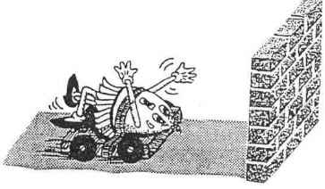

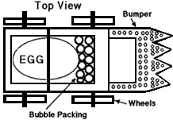

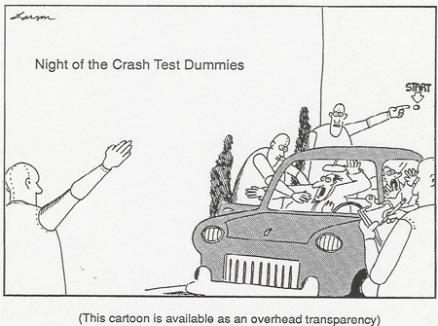

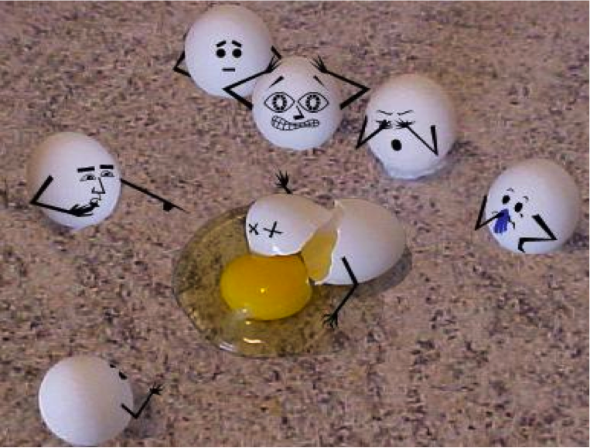

**Egg Crash Vehicle Design Challenge**

*Automobile Frame* Research Worksheet

One of the most important and earliest safety devices of the automotive industry was the design of the automobile body and frame. This should and will be one of the most important features of your vehicle.

In order to research solutions to your problem, please answer the questions below:

|  |
| --- |
| **1. What is the body shell (or frame) of a car?** |
|  |
|  |
|  |
|  |
|  |
| **2. What three jobs are the parts of the body shell (or frame) designed to do?** |
| *1.* |
|  |
| *2.* |
|  |
| *3.* |
|  |
| **Why can “strategic weaknesses” be a strength in vehicle safety?** |
|  |
|  |
|  |
|  |
| **In a collision, what are bumpers good for?** |
|  |
|  |
|  |
|  |
| **Why do bumpers have spring-loaded shock absorbers?** |
|  |
|  |
|  |
|  |
| **What are crumple zones, and what are they good for?** |
|  |
|  |
|  |
|  |
|  |
|  |
| **What is Kinetic Energy?** |
|  |
|  |
|  |
|  |

Automobile Frame

Research Worksheet

Source Sheet

Please list the names of the web site or sites and resources you used to complete the worksheet on the front side of this sheet:

|  |  |
| --- | --- |
| **Web Site Name** | **Web Address** |
|  |  |
|  |  |
|  |  |
|  |  |
|  |  |
|  |  |
|  |  |

**Related Web Sites:**

* *Automobile Safety Timeline -* <http://www.allpar.com/ed/safety.html>
* *Automotive Learning Center -* <http://www.innerauto.com/main.html>
* *National Highway Traffic Safety Administration -* <http://www.nhtsa.dot.gov/>

**Egg Crash Vehicle Design Challenge**

*Interior Safety Features* Research Worksheet

You may believe that the interior safety features of modern automobiles have no place in your design solutions…NOT TRUE! You are required to use wood for the frame of your vehicle, but may use various other materials to construct the passenger compartment of your vehicle.  
  
To further research your problem, answer the following questions concerning interior automotive safety features:

|  |
| --- |
| **How does a seatbelt work?** |
|  |
|  |
|  |
|  |
|  |
|  |
|  |
| **According to the National Highway Traffic and Safety Administration, how many lives a year do seatbelts save?** |
|  |
|  |
| **What is Inertia?** |
|  |
|  |
|  |
| **What is the right way to wear a seatbelt?** |
|  |
|  |
|  |
|  |
|  |
| **What are the basic, or 3 main parts, to an airbag? Please BRIEFLY describe them.** |
| 1. |
|  |
| 2. |
|  |
| 3. |
|  |
| **By what percent do airbags reduce the risk of dying in a frontal crash?** |
|  |
| **Why is it important to wear a safety belt (or seatbelt) even if your vehicle has an airbag?** |
|  |
|  |
|  |
|  |

Interior Safety Features

Research Worksheet

Source Sheet

Please list the names of the web site or sites and resources you used to complete the worksheet on the front side of this sheet:

|  |  |
| --- | --- |
| **Web Site Name** | **Web Address** |
|  |  |
|  |  |
|  |  |
|  |  |
|  |  |
|  |  |
|  |  |

**Related Web Sites:**

* *Automobile Safety Timeline -* <http://www.allpar.com/ed/safety.html>
* *Automotive Learning Center -* <http://www.innerauto.com/main.html>
* *National Highway Traffic Safety Administration -* <http://www.nhtsa.dot.gov/>

**Egg Crash Vehicle Design Challenge**

*Crash Testing* Research Worksheet

Your vehicle will undergo crash testing by your CEO and instructor, Mr. Mandl. The questions below will help to improve your understanding of crash tests, and how to design your car to survive the tests.

To further research your problem, answer the following questions concerning crash tests:

|  |
| --- |
| **Why have cars been getting safer throughout their history?** |
|  |
|  |
|  |
|  |
|  |
| **What is the “PERFECT” crash?** |
|  |
|  |
|  |
|  |
|  |
| **What are Federal Motor Vehicle Safety Standards?** |
|  |
|  |
|  |
| **What are 3 criteria for frontal crashes used in the 5 star rating system?** |
| 1. |
|  |
| 2. |
|  |
| 3. |
|  |
| **What are 2 criteria for side impact crashes used in the 5 star rating system?** |
| 1. |
|  |
| 2. |
|  |

Crash Testing

Research Worksheet

Source Sheet

Please list the names of the web site or sites and resources you used to complete the worksheet on the front side of this sheet:

|  |  |
| --- | --- |
| **Web Site Name** | **Web Address** |
|  |  |
|  |  |
|  |  |
|  |  |
|  |  |
|  |  |
|  |  |

**Related Web Sites:**

* *Automobile Safety Timeline -* <http://www.allpar.com/ed/safety.html>
* *Automotive Learning Center -* <http://www.innerauto.com/main.html>
* *National Highway Traffic Safety Administration -* <http://www.nhtsa.dot.gov/>

**Egg Crash Vehicle Design Challenge**

Initial Concept Phase Worksheet

Please provide three design concepts using the graph paper blocks below. Please sketch these designs to scale, considering that each block is equal to 0.5 inches.

***Design Concept #1: Top View***

|  |  |  |  |  |  |  |  |  |  |  |  |  |  |  |  |  |  |  |  |  |  |  |  |  |  |  |  |  |  |  |  |  |  |  |  |  |  |  |  |
| --- | --- | --- | --- | --- | --- | --- | --- | --- | --- | --- | --- | --- | --- | --- | --- | --- | --- | --- | --- | --- | --- | --- | --- | --- | --- | --- | --- | --- | --- | --- | --- | --- | --- | --- | --- | --- | --- | --- | --- |
|  |  |  |  |  |  |  |  |  |  |  |  |  |  |  |  |  |  |  |  |  |  |  |  |  |  |  |  |  |  |  |  |  |  |  |  |  |  |  |  |
|  |  |  |  |  |  |  |  |  |  |  |  |  |  |  |  |  |  |  |  |  |  |  |  |  |  |  |  |  |  |  |  |  |  |  |  |  |  |  |  |
|  |  |  |  |  |  |  |  |  |  |  |  |  |  |  |  |  |  |  |  |  |  |  |  |  |  |  |  |  |  |  |  |  |  |  |  |  |  |  |  |
|  |  |  |  |  |  |  |  |  |  |  |  |  |  |  |  |  |  |  |  |  |  |  |  |  |  |  |  |  |  |  |  |  |  |  |  |  |  |  |  |
|  |  |  |  |  |  |  |  |  |  |  |  |  |  |  |  |  |  |  |  |  |  |  |  |  |  |  |  |  |  |  |  |  |  |  |  |  |  |  |  |
|  |  |  |  |  |  |  |  |  |  |  |  |  |  |  |  |  |  |  |  |  |  |  |  |  |  |  |  |  |  |  |  |  |  |  |  |  |  |  |  |
|  |  |  |  |  |  |  |  |  |  |  |  |  |  |  |  |  |  |  |  |  |  |  |  |  |  |  |  |  |  |  |  |  |  |  |  |  |  |  |  |
|  |  |  |  |  |  |  |  |  |  |  |  |  |  |  |  |  |  |  |  |  |  |  |  |  |  |  |  |  |  |  |  |  |  |  |  |  |  |  |  |
|  |  |  |  |  |  |  |  |  |  |  |  |  |  |  |  |  |  |  |  |  |  |  |  |  |  |  |  |  |  |  |  |  |  |  |  |  |  |  |  |
|  |  |  |  |  |  |  |  |  |  |  |  |  |  |  |  |  |  |  |  |  |  |  |  |  |  |  |  |  |  |  |  |  |  |  |  |  |  |  |  |
|  |  |  |  |  |  |  |  |  |  |  |  |  |  |  |  |  |  |  |  |  |  |  |  |  |  |  |  |  |  |  |  |  |  |  |  |  |  |  |  |
|  |  |  |  |  |  |  |  |  |  |  |  |  |  |  |  |  |  |  |  |  |  |  |  |  |  |  |  |  |  |  |  |  |  |  |  |  |  |  |  |
|  |  |  |  |  |  |  |  |  |  |  |  |  |  |  |  |  |  |  |  |  |  |  |  |  |  |  |  |  |  |  |  |  |  |  |  |  |  |  |  |
|  |  |  |  |  |  |  |  |  |  |  |  |  |  |  |  |  |  |  |  |  |  |  |  |  |  |  |  |  |  |  |  |  |  |  |  |  |  |  |  |
|  |  |  |  |  |  |  |  |  |  |  |  |  |  |  |  |  |  |  |  |  |  |  |  |  |  |  |  |  |  |  |  |  |  |  |  |  |  |  |  |
|  |  |  |  |  |  |  |  |  |  |  |  |  |  |  |  |  |  |  |  |  |  |  |  |  |  |  |  |  |  |  |  |  |  |  |  |  |  |  |  |
|  |  |  |  |  |  |  |  |  |  |  |  |  |  |  |  |  |  |  |  |  |  |  |  |  |  |  |  |  |  |  |  |  |  |  |  |  |  |  |  |
|  |  |  |  |  |  |  |  |  |  |  |  |  |  |  |  |  |  |  |  |  |  |  |  |  |  |  |  |  |  |  |  |  |  |  |  |  |  |  |  |
|  |  |  |  |  |  |  |  |  |  |  |  |  |  |  |  |  |  |  |  |  |  |  |  |  |  |  |  |  |  |  |  |  |  |  |  |  |  |  |  |
|  |  |  |  |  |  |  |  |  |  |  |  |  |  |  |  |  |  |  |  |  |  |  |  |  |  |  |  |  |  |  |  |  |  |  |  |  |  |  |  |

***Design Concept #1: Side View***

|  |  |  |  |  |  |  |  |  |  |  |  |  |  |  |  |  |  |  |  |  |  |  |  |  |  |  |  |  |  |  |  |  |  |  |  |  |  |  |  |
| --- | --- | --- | --- | --- | --- | --- | --- | --- | --- | --- | --- | --- | --- | --- | --- | --- | --- | --- | --- | --- | --- | --- | --- | --- | --- | --- | --- | --- | --- | --- | --- | --- | --- | --- | --- | --- | --- | --- | --- |
|  |  |  |  |  |  |  |  |  |  |  |  |  |  |  |  |  |  |  |  |  |  |  |  |  |  |  |  |  |  |  |  |  |  |  |  |  |  |  |  |
|  |  |  |  |  |  |  |  |  |  |  |  |  |  |  |  |  |  |  |  |  |  |  |  |  |  |  |  |  |  |  |  |  |  |  |  |  |  |  |  |
|  |  |  |  |  |  |  |  |  |  |  |  |  |  |  |  |  |  |  |  |  |  |  |  |  |  |  |  |  |  |  |  |  |  |  |  |  |  |  |  |
|  |  |  |  |  |  |  |  |  |  |  |  |  |  |  |  |  |  |  |  |  |  |  |  |  |  |  |  |  |  |  |  |  |  |  |  |  |  |  |  |
|  |  |  |  |  |  |  |  |  |  |  |  |  |  |  |  |  |  |  |  |  |  |  |  |  |  |  |  |  |  |  |  |  |  |  |  |  |  |  |  |
|  |  |  |  |  |  |  |  |  |  |  |  |  |  |  |  |  |  |  |  |  |  |  |  |  |  |  |  |  |  |  |  |  |  |  |  |  |  |  |  |
|  |  |  |  |  |  |  |  |  |  |  |  |  |  |  |  |  |  |  |  |  |  |  |  |  |  |  |  |  |  |  |  |  |  |  |  |  |  |  |  |
|  |  |  |  |  |  |  |  |  |  |  |  |  |  |  |  |  |  |  |  |  |  |  |  |  |  |  |  |  |  |  |  |  |  |  |  |  |  |  |  |
|  |  |  |  |  |  |  |  |  |  |  |  |  |  |  |  |  |  |  |  |  |  |  |  |  |  |  |  |  |  |  |  |  |  |  |  |  |  |  |  |
|  |  |  |  |  |  |  |  |  |  |  |  |  |  |  |  |  |  |  |  |  |  |  |  |  |  |  |  |  |  |  |  |  |  |  |  |  |  |  |  |
|  |  |  |  |  |  |  |  |  |  |  |  |  |  |  |  |  |  |  |  |  |  |  |  |  |  |  |  |  |  |  |  |  |  |  |  |  |  |  |  |
|  |  |  |  |  |  |  |  |  |  |  |  |  |  |  |  |  |  |  |  |  |  |  |  |  |  |  |  |  |  |  |  |  |  |  |  |  |  |  |  |
|  |  |  |  |  |  |  |  |  |  |  |  |  |  |  |  |  |  |  |  |  |  |  |  |  |  |  |  |  |  |  |  |  |  |  |  |  |  |  |  |
|  |  |  |  |  |  |  |  |  |  |  |  |  |  |  |  |  |  |  |  |  |  |  |  |  |  |  |  |  |  |  |  |  |  |  |  |  |  |  |  |
|  |  |  |  |  |  |  |  |  |  |  |  |  |  |  |  |  |  |  |  |  |  |  |  |  |  |  |  |  |  |  |  |  |  |  |  |  |  |  |  |
|  |  |  |  |  |  |  |  |  |  |  |  |  |  |  |  |  |  |  |  |  |  |  |  |  |  |  |  |  |  |  |  |  |  |  |  |  |  |  |  |
|  |  |  |  |  |  |  |  |  |  |  |  |  |  |  |  |  |  |  |  |  |  |  |  |  |  |  |  |  |  |  |  |  |  |  |  |  |  |  |  |
|  |  |  |  |  |  |  |  |  |  |  |  |  |  |  |  |  |  |  |  |  |  |  |  |  |  |  |  |  |  |  |  |  |  |  |  |  |  |  |  |
|  |  |  |  |  |  |  |  |  |  |  |  |  |  |  |  |  |  |  |  |  |  |  |  |  |  |  |  |  |  |  |  |  |  |  |  |  |  |  |  |
|  |  |  |  |  |  |  |  |  |  |  |  |  |  |  |  |  |  |  |  |  |  |  |  |  |  |  |  |  |  |  |  |  |  |  |  |  |  |  |  |

**Egg Crash Vehicle Design Challenge**

Initial Concept Phase Worksheet

Please provide three design concepts using the graph paper blocks below. Please sketch these designs to scale, considering that each block is equal to 0.5 inches.

***Design Concept #2: Top View***

|  |  |  |  |  |  |  |  |  |  |  |  |  |  |  |  |  |  |  |  |  |  |  |  |  |  |  |  |  |  |  |  |  |  |  |  |  |  |  |  |
| --- | --- | --- | --- | --- | --- | --- | --- | --- | --- | --- | --- | --- | --- | --- | --- | --- | --- | --- | --- | --- | --- | --- | --- | --- | --- | --- | --- | --- | --- | --- | --- | --- | --- | --- | --- | --- | --- | --- | --- |
|  |  |  |  |  |  |  |  |  |  |  |  |  |  |  |  |  |  |  |  |  |  |  |  |  |  |  |  |  |  |  |  |  |  |  |  |  |  |  |  |
|  |  |  |  |  |  |  |  |  |  |  |  |  |  |  |  |  |  |  |  |  |  |  |  |  |  |  |  |  |  |  |  |  |  |  |  |  |  |  |  |
|  |  |  |  |  |  |  |  |  |  |  |  |  |  |  |  |  |  |  |  |  |  |  |  |  |  |  |  |  |  |  |  |  |  |  |  |  |  |  |  |
|  |  |  |  |  |  |  |  |  |  |  |  |  |  |  |  |  |  |  |  |  |  |  |  |  |  |  |  |  |  |  |  |  |  |  |  |  |  |  |  |
|  |  |  |  |  |  |  |  |  |  |  |  |  |  |  |  |  |  |  |  |  |  |  |  |  |  |  |  |  |  |  |  |  |  |  |  |  |  |  |  |
|  |  |  |  |  |  |  |  |  |  |  |  |  |  |  |  |  |  |  |  |  |  |  |  |  |  |  |  |  |  |  |  |  |  |  |  |  |  |  |  |
|  |  |  |  |  |  |  |  |  |  |  |  |  |  |  |  |  |  |  |  |  |  |  |  |  |  |  |  |  |  |  |  |  |  |  |  |  |  |  |  |
|  |  |  |  |  |  |  |  |  |  |  |  |  |  |  |  |  |  |  |  |  |  |  |  |  |  |  |  |  |  |  |  |  |  |  |  |  |  |  |  |
|  |  |  |  |  |  |  |  |  |  |  |  |  |  |  |  |  |  |  |  |  |  |  |  |  |  |  |  |  |  |  |  |  |  |  |  |  |  |  |  |
|  |  |  |  |  |  |  |  |  |  |  |  |  |  |  |  |  |  |  |  |  |  |  |  |  |  |  |  |  |  |  |  |  |  |  |  |  |  |  |  |
|  |  |  |  |  |  |  |  |  |  |  |  |  |  |  |  |  |  |  |  |  |  |  |  |  |  |  |  |  |  |  |  |  |  |  |  |  |  |  |  |
|  |  |  |  |  |  |  |  |  |  |  |  |  |  |  |  |  |  |  |  |  |  |  |  |  |  |  |  |  |  |  |  |  |  |  |  |  |  |  |  |
|  |  |  |  |  |  |  |  |  |  |  |  |  |  |  |  |  |  |  |  |  |  |  |  |  |  |  |  |  |  |  |  |  |  |  |  |  |  |  |  |
|  |  |  |  |  |  |  |  |  |  |  |  |  |  |  |  |  |  |  |  |  |  |  |  |  |  |  |  |  |  |  |  |  |  |  |  |  |  |  |  |
|  |  |  |  |  |  |  |  |  |  |  |  |  |  |  |  |  |  |  |  |  |  |  |  |  |  |  |  |  |  |  |  |  |  |  |  |  |  |  |  |
|  |  |  |  |  |  |  |  |  |  |  |  |  |  |  |  |  |  |  |  |  |  |  |  |  |  |  |  |  |  |  |  |  |  |  |  |  |  |  |  |
|  |  |  |  |  |  |  |  |  |  |  |  |  |  |  |  |  |  |  |  |  |  |  |  |  |  |  |  |  |  |  |  |  |  |  |  |  |  |  |  |
|  |  |  |  |  |  |  |  |  |  |  |  |  |  |  |  |  |  |  |  |  |  |  |  |  |  |  |  |  |  |  |  |  |  |  |  |  |  |  |  |
|  |  |  |  |  |  |  |  |  |  |  |  |  |  |  |  |  |  |  |  |  |  |  |  |  |  |  |  |  |  |  |  |  |  |  |  |  |  |  |  |
|  |  |  |  |  |  |  |  |  |  |  |  |  |  |  |  |  |  |  |  |  |  |  |  |  |  |  |  |  |  |  |  |  |  |  |  |  |  |  |  |

***Design Concept #2: Side View***

|  |  |  |  |  |  |  |  |  |  |  |  |  |  |  |  |  |  |  |  |  |  |  |  |  |  |  |  |  |  |  |  |  |  |  |  |  |  |  |  |
| --- | --- | --- | --- | --- | --- | --- | --- | --- | --- | --- | --- | --- | --- | --- | --- | --- | --- | --- | --- | --- | --- | --- | --- | --- | --- | --- | --- | --- | --- | --- | --- | --- | --- | --- | --- | --- | --- | --- | --- |
|  |  |  |  |  |  |  |  |  |  |  |  |  |  |  |  |  |  |  |  |  |  |  |  |  |  |  |  |  |  |  |  |  |  |  |  |  |  |  |  |
|  |  |  |  |  |  |  |  |  |  |  |  |  |  |  |  |  |  |  |  |  |  |  |  |  |  |  |  |  |  |  |  |  |  |  |  |  |  |  |  |
|  |  |  |  |  |  |  |  |  |  |  |  |  |  |  |  |  |  |  |  |  |  |  |  |  |  |  |  |  |  |  |  |  |  |  |  |  |  |  |  |
|  |  |  |  |  |  |  |  |  |  |  |  |  |  |  |  |  |  |  |  |  |  |  |  |  |  |  |  |  |  |  |  |  |  |  |  |  |  |  |  |
|  |  |  |  |  |  |  |  |  |  |  |  |  |  |  |  |  |  |  |  |  |  |  |  |  |  |  |  |  |  |  |  |  |  |  |  |  |  |  |  |
|  |  |  |  |  |  |  |  |  |  |  |  |  |  |  |  |  |  |  |  |  |  |  |  |  |  |  |  |  |  |  |  |  |  |  |  |  |  |  |  |
|  |  |  |  |  |  |  |  |  |  |  |  |  |  |  |  |  |  |  |  |  |  |  |  |  |  |  |  |  |  |  |  |  |  |  |  |  |  |  |  |
|  |  |  |  |  |  |  |  |  |  |  |  |  |  |  |  |  |  |  |  |  |  |  |  |  |  |  |  |  |  |  |  |  |  |  |  |  |  |  |  |
|  |  |  |  |  |  |  |  |  |  |  |  |  |  |  |  |  |  |  |  |  |  |  |  |  |  |  |  |  |  |  |  |  |  |  |  |  |  |  |  |
|  |  |  |  |  |  |  |  |  |  |  |  |  |  |  |  |  |  |  |  |  |  |  |  |  |  |  |  |  |  |  |  |  |  |  |  |  |  |  |  |
|  |  |  |  |  |  |  |  |  |  |  |  |  |  |  |  |  |  |  |  |  |  |  |  |  |  |  |  |  |  |  |  |  |  |  |  |  |  |  |  |
|  |  |  |  |  |  |  |  |  |  |  |  |  |  |  |  |  |  |  |  |  |  |  |  |  |  |  |  |  |  |  |  |  |  |  |  |  |  |  |  |
|  |  |  |  |  |  |  |  |  |  |  |  |  |  |  |  |  |  |  |  |  |  |  |  |  |  |  |  |  |  |  |  |  |  |  |  |  |  |  |  |
|  |  |  |  |  |  |  |  |  |  |  |  |  |  |  |  |  |  |  |  |  |  |  |  |  |  |  |  |  |  |  |  |  |  |  |  |  |  |  |  |
|  |  |  |  |  |  |  |  |  |  |  |  |  |  |  |  |  |  |  |  |  |  |  |  |  |  |  |  |  |  |  |  |  |  |  |  |  |  |  |  |
|  |  |  |  |  |  |  |  |  |  |  |  |  |  |  |  |  |  |  |  |  |  |  |  |  |  |  |  |  |  |  |  |  |  |  |  |  |  |  |  |
|  |  |  |  |  |  |  |  |  |  |  |  |  |  |  |  |  |  |  |  |  |  |  |  |  |  |  |  |  |  |  |  |  |  |  |  |  |  |  |  |
|  |  |  |  |  |  |  |  |  |  |  |  |  |  |  |  |  |  |  |  |  |  |  |  |  |  |  |  |  |  |  |  |  |  |  |  |  |  |  |  |
|  |  |  |  |  |  |  |  |  |  |  |  |  |  |  |  |  |  |  |  |  |  |  |  |  |  |  |  |  |  |  |  |  |  |  |  |  |  |  |  |
|  |  |  |  |  |  |  |  |  |  |  |  |  |  |  |  |  |  |  |  |  |  |  |  |  |  |  |  |  |  |  |  |  |  |  |  |  |  |  |  |

**Egg Crash Vehicle Design Challenge**

Initial Concept Phase Worksheet

Please provide three design concepts using the graph paper blocks below. Please sketch these designs to scale, considering that each block is equal to 0.5 inches.

***Design Concept #3: Top View***

|  |  |  |  |  |  |  |  |  |  |  |  |  |  |  |  |  |  |  |  |  |  |  |  |  |  |  |  |  |  |  |  |  |  |  |  |  |  |  |  |
| --- | --- | --- | --- | --- | --- | --- | --- | --- | --- | --- | --- | --- | --- | --- | --- | --- | --- | --- | --- | --- | --- | --- | --- | --- | --- | --- | --- | --- | --- | --- | --- | --- | --- | --- | --- | --- | --- | --- | --- |
|  |  |  |  |  |  |  |  |  |  |  |  |  |  |  |  |  |  |  |  |  |  |  |  |  |  |  |  |  |  |  |  |  |  |  |  |  |  |  |  |
|  |  |  |  |  |  |  |  |  |  |  |  |  |  |  |  |  |  |  |  |  |  |  |  |  |  |  |  |  |  |  |  |  |  |  |  |  |  |  |  |
|  |  |  |  |  |  |  |  |  |  |  |  |  |  |  |  |  |  |  |  |  |  |  |  |  |  |  |  |  |  |  |  |  |  |  |  |  |  |  |  |
|  |  |  |  |  |  |  |  |  |  |  |  |  |  |  |  |  |  |  |  |  |  |  |  |  |  |  |  |  |  |  |  |  |  |  |  |  |  |  |  |
|  |  |  |  |  |  |  |  |  |  |  |  |  |  |  |  |  |  |  |  |  |  |  |  |  |  |  |  |  |  |  |  |  |  |  |  |  |  |  |  |
|  |  |  |  |  |  |  |  |  |  |  |  |  |  |  |  |  |  |  |  |  |  |  |  |  |  |  |  |  |  |  |  |  |  |  |  |  |  |  |  |
|  |  |  |  |  |  |  |  |  |  |  |  |  |  |  |  |  |  |  |  |  |  |  |  |  |  |  |  |  |  |  |  |  |  |  |  |  |  |  |  |
|  |  |  |  |  |  |  |  |  |  |  |  |  |  |  |  |  |  |  |  |  |  |  |  |  |  |  |  |  |  |  |  |  |  |  |  |  |  |  |  |
|  |  |  |  |  |  |  |  |  |  |  |  |  |  |  |  |  |  |  |  |  |  |  |  |  |  |  |  |  |  |  |  |  |  |  |  |  |  |  |  |
|  |  |  |  |  |  |  |  |  |  |  |  |  |  |  |  |  |  |  |  |  |  |  |  |  |  |  |  |  |  |  |  |  |  |  |  |  |  |  |  |
|  |  |  |  |  |  |  |  |  |  |  |  |  |  |  |  |  |  |  |  |  |  |  |  |  |  |  |  |  |  |  |  |  |  |  |  |  |  |  |  |
|  |  |  |  |  |  |  |  |  |  |  |  |  |  |  |  |  |  |  |  |  |  |  |  |  |  |  |  |  |  |  |  |  |  |  |  |  |  |  |  |
|  |  |  |  |  |  |  |  |  |  |  |  |  |  |  |  |  |  |  |  |  |  |  |  |  |  |  |  |  |  |  |  |  |  |  |  |  |  |  |  |
|  |  |  |  |  |  |  |  |  |  |  |  |  |  |  |  |  |  |  |  |  |  |  |  |  |  |  |  |  |  |  |  |  |  |  |  |  |  |  |  |
|  |  |  |  |  |  |  |  |  |  |  |  |  |  |  |  |  |  |  |  |  |  |  |  |  |  |  |  |  |  |  |  |  |  |  |  |  |  |  |  |
|  |  |  |  |  |  |  |  |  |  |  |  |  |  |  |  |  |  |  |  |  |  |  |  |  |  |  |  |  |  |  |  |  |  |  |  |  |  |  |  |
|  |  |  |  |  |  |  |  |  |  |  |  |  |  |  |  |  |  |  |  |  |  |  |  |  |  |  |  |  |  |  |  |  |  |  |  |  |  |  |  |
|  |  |  |  |  |  |  |  |  |  |  |  |  |  |  |  |  |  |  |  |  |  |  |  |  |  |  |  |  |  |  |  |  |  |  |  |  |  |  |  |
|  |  |  |  |  |  |  |  |  |  |  |  |  |  |  |  |  |  |  |  |  |  |  |  |  |  |  |  |  |  |  |  |  |  |  |  |  |  |  |  |
|  |  |  |  |  |  |  |  |  |  |  |  |  |  |  |  |  |  |  |  |  |  |  |  |  |  |  |  |  |  |  |  |  |  |  |  |  |  |  |  |

***Design Concept #3: Side View***

|  |  |  |  |  |  |  |  |  |  |  |  |  |  |  |  |  |  |  |  |  |  |  |  |  |  |  |  |  |  |  |  |  |  |  |  |  |  |  |  |
| --- | --- | --- | --- | --- | --- | --- | --- | --- | --- | --- | --- | --- | --- | --- | --- | --- | --- | --- | --- | --- | --- | --- | --- | --- | --- | --- | --- | --- | --- | --- | --- | --- | --- | --- | --- | --- | --- | --- | --- |
|  |  |  |  |  |  |  |  |  |  |  |  |  |  |  |  |  |  |  |  |  |  |  |  |  |  |  |  |  |  |  |  |  |  |  |  |  |  |  |  |
|  |  |  |  |  |  |  |  |  |  |  |  |  |  |  |  |  |  |  |  |  |  |  |  |  |  |  |  |  |  |  |  |  |  |  |  |  |  |  |  |
|  |  |  |  |  |  |  |  |  |  |  |  |  |  |  |  |  |  |  |  |  |  |  |  |  |  |  |  |  |  |  |  |  |  |  |  |  |  |  |  |
|  |  |  |  |  |  |  |  |  |  |  |  |  |  |  |  |  |  |  |  |  |  |  |  |  |  |  |  |  |  |  |  |  |  |  |  |  |  |  |  |
|  |  |  |  |  |  |  |  |  |  |  |  |  |  |  |  |  |  |  |  |  |  |  |  |  |  |  |  |  |  |  |  |  |  |  |  |  |  |  |  |
|  |  |  |  |  |  |  |  |  |  |  |  |  |  |  |  |  |  |  |  |  |  |  |  |  |  |  |  |  |  |  |  |  |  |  |  |  |  |  |  |
|  |  |  |  |  |  |  |  |  |  |  |  |  |  |  |  |  |  |  |  |  |  |  |  |  |  |  |  |  |  |  |  |  |  |  |  |  |  |  |  |
|  |  |  |  |  |  |  |  |  |  |  |  |  |  |  |  |  |  |  |  |  |  |  |  |  |  |  |  |  |  |  |  |  |  |  |  |  |  |  |  |
|  |  |  |  |  |  |  |  |  |  |  |  |  |  |  |  |  |  |  |  |  |  |  |  |  |  |  |  |  |  |  |  |  |  |  |  |  |  |  |  |
|  |  |  |  |  |  |  |  |  |  |  |  |  |  |  |  |  |  |  |  |  |  |  |  |  |  |  |  |  |  |  |  |  |  |  |  |  |  |  |  |
|  |  |  |  |  |  |  |  |  |  |  |  |  |  |  |  |  |  |  |  |  |  |  |  |  |  |  |  |  |  |  |  |  |  |  |  |  |  |  |  |
|  |  |  |  |  |  |  |  |  |  |  |  |  |  |  |  |  |  |  |  |  |  |  |  |  |  |  |  |  |  |  |  |  |  |  |  |  |  |  |  |
|  |  |  |  |  |  |  |  |  |  |  |  |  |  |  |  |  |  |  |  |  |  |  |  |  |  |  |  |  |  |  |  |  |  |  |  |  |  |  |  |
|  |  |  |  |  |  |  |  |  |  |  |  |  |  |  |  |  |  |  |  |  |  |  |  |  |  |  |  |  |  |  |  |  |  |  |  |  |  |  |  |
|  |  |  |  |  |  |  |  |  |  |  |  |  |  |  |  |  |  |  |  |  |  |  |  |  |  |  |  |  |  |  |  |  |  |  |  |  |  |  |  |
|  |  |  |  |  |  |  |  |  |  |  |  |  |  |  |  |  |  |  |  |  |  |  |  |  |  |  |  |  |  |  |  |  |  |  |  |  |  |  |  |
|  |  |  |  |  |  |  |  |  |  |  |  |  |  |  |  |  |  |  |  |  |  |  |  |  |  |  |  |  |  |  |  |  |  |  |  |  |  |  |  |
|  |  |  |  |  |  |  |  |  |  |  |  |  |  |  |  |  |  |  |  |  |  |  |  |  |  |  |  |  |  |  |  |  |  |  |  |  |  |  |  |
|  |  |  |  |  |  |  |  |  |  |  |  |  |  |  |  |  |  |  |  |  |  |  |  |  |  |  |  |  |  |  |  |  |  |  |  |  |  |  |  |
|  |  |  |  |  |  |  |  |  |  |  |  |  |  |  |  |  |  |  |  |  |  |  |  |  |  |  |  |  |  |  |  |  |  |  |  |  |  |  |  |

Standards Covered in Detail

***Academic Standards for Science and Technology***

###### Unifying Themes

* Discriminate among the concepts of systems, subsystems, feedback, and control in solving technological problems.
* Describe the concepts of models as a way to predict and understand science and technology.
* Apply scale as a way of relating concepts and ideas to one another by some measure.
* Describe patterns of change in nature and man made systems.

###### Inquiry and Design

* Apply process knowledge and organize scientific and technological phenomena in varied ways.
* Identify and apply the technological design process to solve problems.

###### Physical Science, Chemistry and Physics

* Distinguish among the principles of force and motion.

###### Technology Education

* Apply knowledge of information technologies of encoding, transmitting, receiving, storing,   
  retrieving, and decoding.
* Apply physical technologies of structural design, analysis and engineering, personnel relations, financial affairs, structural production, marketing, research and design to real world problems.

###### Technological Devices

* Identify and safely use a variety of tools, basic machines, materials, and techniques to solve problems and answer questions
* Apply appropriate instruments and apparatus to examine a variety of objects and processes.
* Apply basic computer operations and concepts.
* Utilize computer software to solve specific problems.

***Academic Standards for Reading, Writing, Speaking & Listening***

*Types of Writing*

* Write complex informational pieces (e.g., research papers, analyses, evaluations, essays).
* Maintain a written record of activities, course work, experience, honors and interests.

*Quality of Writing*

* Write with a sharp, distinct focus.
* Write using well-developed content appropriate for the topic.
* Edit writing using the conventions of language.

*Speaking & Listening*

* Listen to others.
* Contribute to discussions.
* Participate in small and large group discussions and presentations.
* Use media for learning purposes.

***Academic Standards for Health, Safety and Physical Education***

*Safety and Injury Prevention*

* Analyze the role of individual responsibility for safe practices and injury prevention in the home, school and community