PROJECT-BASED LEARNING:
CHRISTMAS ORNAMENT DESIGN

Description  Today, you interviewed for a position with a newly created subsidiary of Bronner’s Christmas Wonderland in Frankenmuth, Michigan.  They are looking for ornament designers who will create unique, special order ornaments for customers using SolidWorks, NX and 3D printing.  As a pre-employment test, you are being asked to spend the day at the company to come up with a design that will be 3D printed. | Requirements  For the ornament design, an ideal ornament will:  1. Have a place for a hanger (hook)  2. Have a total volume of no more than 12.5  cubic inches  3. Be incredibly eye appealing – all edges  filleted  4. Have an easily recognizable theme
Deliverables

- Hand Sketch
- 3D Data (Portfolio Page with top, front, side and ISO views)
- STL File (To be emailed to jmandl@wcskids.net)
- Executive Summary with Volume

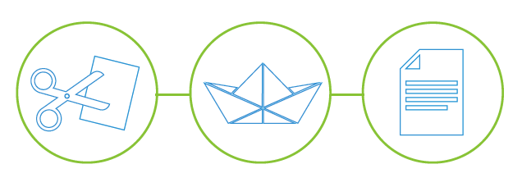
CPC CAD: PROJECT-BASED LEARNING | CHRISMAS ORNAMENT DESIGN

Preliminary Work

Directions: (Use this page to sketch your design ideas)

Name:
Date:
Block:
CPC CAD: PROJECT-BASED LEARNING | BOAT DESIGN

Portfolio Page

Insert screen shots of your design
Top View | Iso View
Front View | Side View

Name:
Date:
Block:
CPC CAD: PROJECT-BASED LEARNING | BOAT DESIGN

Executive Summary (Type a short paragraph using complete sentences describing your design)

Insert a screen shot of your volume
Ornament Volume Proof

Name:
Date:
Block:

CPC CAD: PROJECT-BASED LEARNING | BOAT DESIGN

Assessment Rubric

 | BEGINNER  1 | INTERMEDIATE  3 | ADVANCED  5
SKETCHES | Planning sketches are either missing or lacking detail or lacking effort or any combination of the above. | Planning sketches are included, but to not appear to show much effort. | Planning sketches are complete and easy to understand.
DOCUMENTATION | Documentation is incomplete, missing verbal or Photographic explanation, or both. | Documentation contains explanations and photos, but is not thorough. | Documentation of the design process is clear and thorough with photos and explanation.
DATA FEATURES | Design is missing all of the following:  - Hanger  - Fillets  - Theme  - Eye Appeal | Design is missing some of the following:  - Hanger  - Fillets  - Theme  - Eye Appeal | Design has all of the following:  - Hanger  - Fillets  - Theme  - Eye Appeal
VOLUME | Volume of the design exceeds 12.5 cubic inch limit. |  | Volume of the design does not exceed 12.5 cubic inch limit.
TOTAL SCORE: /20

Name:
Date:
Block:

