NAME
BLOCK
DATE
Your Experience with Work
- Have you have ever had a job?
- If So Where did you work?
- What did you do?
- Have you ever been hurt at work, or do you know someone who was?
- Have you ever been uncomfortable with a task you’ve been asked to do at work?
Examples of Teen Work Injuries: John’s Story
John worked at a fast food restaurant. The floor often got very greasy, and had to be washed a lot. As John walked across the wet floor, carrying a basket of French fries, he slipped. He tried to keep the fries from falling, so he couldn’t break his fall with his hands. He fell on his tailbone and was seriously injured. He is now permanently disabled and has trouble walking.
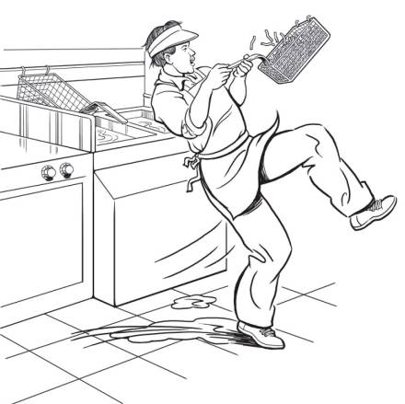
6. What is John’s Job?
7. What is John’s Injury?
8. Why do you think this happened?
7. What could have prevented John from getting hurt?
Teen Work Injuries Antonio’s Story
Antonio worked for a neighborhood builder. One day when he was carrying a 12-foot roof rafter along the top of an unfinished house, he backed into an unguarded chimney hole and plunged 28 feet to a concrete cellar floor below. He survived, but with three cracked vertebrae that forced him to spend the next three months locked in a “clamshell” brace from his neck to his hips.

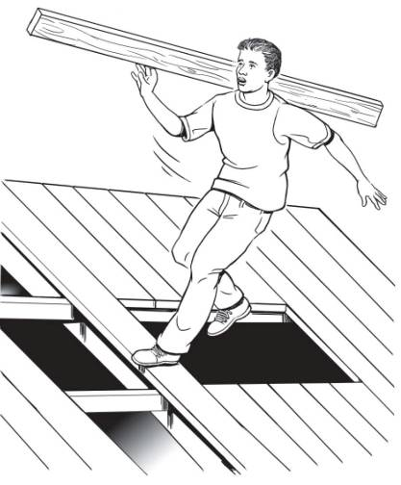
8. What is Antonio’s Job?
9. What is Antonio’s Injury?
10. Why do you think this happened?
11. What could have prevented Antonio from falling?
Teen Work Injuries Keisha’s Story
Keisha did much of her homework on the computer and spent time each day e-mailing her friends. In addition, she worked three hours a day after school inputting data for a direct mail company. She was paid by “piece work” (by the amount of work, not the amount of time). She never took breaks. She began getting numbness in her fingers and waking up with a burning sensation in her wrist. Her doctor told her she has severe repetitive stress injury (RSI), in which prolonged typing in an awkward position damages muscles, tendons, and nerves. She now must wear braces on her wrists day and night and can’t work on the computer for more than 15 minutes at a time. Her high school has arranged for someone to take notes in class for her, and when she goes to college she will have to use special software that allows her to dictate rather than type her papers.
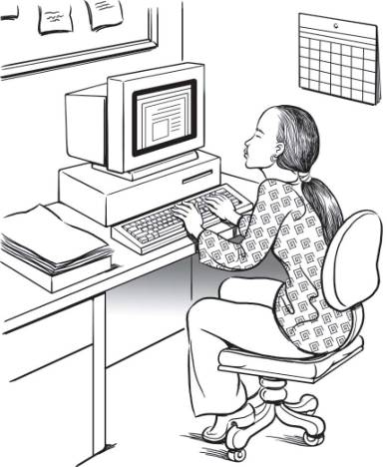
12. What is Keisha’s Job?
13. What is Keisha’s Injury?
14. Why do you think this happened?
15. What could have prevented Keisha from getting hurt?
Teen Work Injuries Francisco’s Story
Robert was a 15-year-old boy who found work with a landscape company after moving to Maryland with his family. After only a week on the job he was assigned to help spread mulch at a large residence using a motorized grinding mulch blower. Somehow, he got up where the mulch mix is fed into the top of the machine, and fell into the grinding machinery of the mulch-spreading truck. A co-worker found his remains soon after.
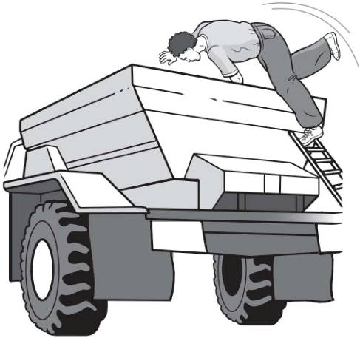
16. What is Robert’s Job?
17. What is Robert’s Injury?
18. Why do you think this happened?
19. What could have prevented Robert from being killed?

Teen Work Injury Statistics
- Many youth are injured on the job:
  - 158,000 <18-year-olds injured/year in the US
  - 52,600 <18-year-olds to the ER for work injuries
  - 38 <18-year-olds die each year
- Young workers are injured at a higher rate than adult workers.
More teens tend to be injured in the industries where a lot of young people work. Since a little over 50% of teens work in retail, which includes fast food restaurants, most injuries occur in retail.

